**What is Tiny10 (Lightweight Windows 10) and How to Install It**

[**[author-Arjun Sha](https://beebom.com/author/arjun/)Arjun Sha**](https://beebom.com/author/arjun/)**- Last Updated: April 6, 2022 4:51 pm**

**https://beebom.com/what-is-tiny10-lightweight-windows-10-how-to-install/**

We love the fact that [Windows 11 is feature-rich](https://beebom.com/best-windows-11-features/) and visually modern, although there are some UI inconsistencies that [Rectify11](https://beebom.com/what-is-rectify11-how-to-install/) has fixed to a large extent. Apart from that, Microsoft has been adding several new features to its desktop OS since Windows 10 days. Fast forward, and both Windows 10 and 11 are bloated with new features, unnecessary apps, and redundant background services. To be frank, Windows 10/11 feels quite heavy compared to Windows 7. And now, to trim down Windows 10 to its bare essentials, a developer has released Tiny10, which is a lightweight version of Windows 10. It takes much less space, works even on low RAM computers, and comes with no bloatware. To find out what is Tiny10 and how to install it, keep on reading.

**Everything You Need to Know About Tiny10 (2022)**

We have discussed everything about Tiny10 and how lightweight it is in comparison to the vanilla Windows 10 installation. We have also included a tutorial on how to install Tiny10 on any PC (both 32-bit and 64-bit). You can also read our first impression of Tiny10, the super powerful and lightweight Windows 10 build, towards the end.

**Table of Contents**

**Stripped Down Windows 10: What is Tiny10?**

Tiny10 is a **stripped-down version of Windows 10**, and it has been developed by a developer named [NTDEV](https://twitter.com/ntdev_). We know how bloated Windows has become at this point, so this project aims to remove all the unnecessary components. That means you can run Windows 10 smoothly, even on low-end hardware. Note that Tiny10 has not just removed bloatware, but it has been optimized from the ground up to reduce Windows 10’s footprint.

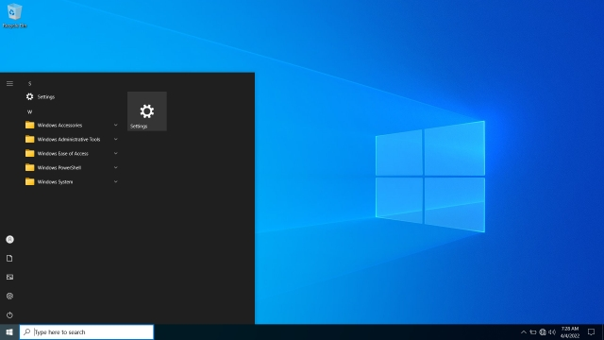

For example, if you install Tiny10 on a 32-bit system, it only **takes 5.2GB of disk space**, which is a breakthrough. A **vanilla Windows 10 system takes up to 22GB of space**. To reduce the installation size by 17GB is just great. On 64-bit systems, Tiny10 takes up to 10GB of disk space. And in terms of RAM, you can run Tiny10 on a 32-bit system with just 1GB of RAM, and on a 64-bit system, you can make do with 2GB of RAM, which is nothing short of amazing. We already know Windows 10 comes to a grinding halt, even on a system with 4GB of RAM.

Now, you might be wondering since Windows 10 has been reduced to such a lightweight profile, is it missing features? Well, I extensively tested Tiny10 and everything worked fine without any bugs. All the **core Windows system tools are available**, including PowerShell, CMD, Disk Management, etc. I even ran a number of applications, including Geekbench, Crystaldisk, ShareX, and games like CS: GO, and everything ran without any issues. It’s a surprise to me as well because we are testing the first beta of Tiny10 for x64 systems. But I can say for sure that you are not going to miss anything on Tiny10 in terms of functionality.

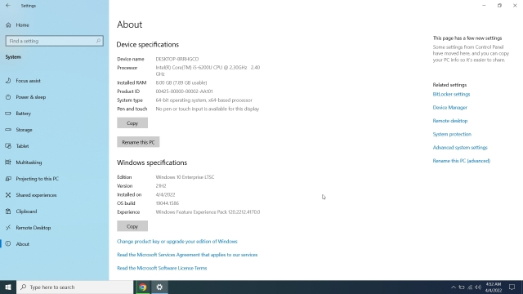

As for the apps, Tiny10 has **removed all the default apps**like the image viewer, internet explorer, media player, etc. Only Notepad and Wordpad are available on this stripped-down build of Windows 10. Moreover, it’s important to know that**Tiny10 does not come with Microsoft Store or Windows Security**. You will need to sideload the apps you want.

Also, there is no support for [Windows Subsystem for Linux](https://beebom.com/install-wsl-windows-10-single-command/), but you can enable [Hyper-V](https://beebom.com/how-create-virtual-machine-windows-10/). As for the Windows version, Tiny10 x64 Beta 1 runs Windows 10 Enterprise LTSC (Build 19044.1586, March 2022). That means you can activate Tiny 10 with a Windows license, but it does not support Windows updates.

Having said all of that, Tiny10 is a great solution for users who want to **run lightweight Windows 10** on a low-end PC with little disk space and RAM. [Chrome OS Flex](https://beebom.com/how-install-chrome-os-flex-windows-laptop-macbook/) is another great solution, but it does not support full-fledged Windows apps. In such a scenario, Tiny10 fills the shoes and can breathe a new life into aging PCs.

**Differences Between Tiny10 and Windows 10**

To begin with, Tiny10 is fast and fluid in comparison to vanilla Windows 10. There is no bloatware to be found on Tiny10. All the bloatware, unnecessary apps, services, and system components have been removed by the developer. For example, you can check out **the difference in the Start menu** below.

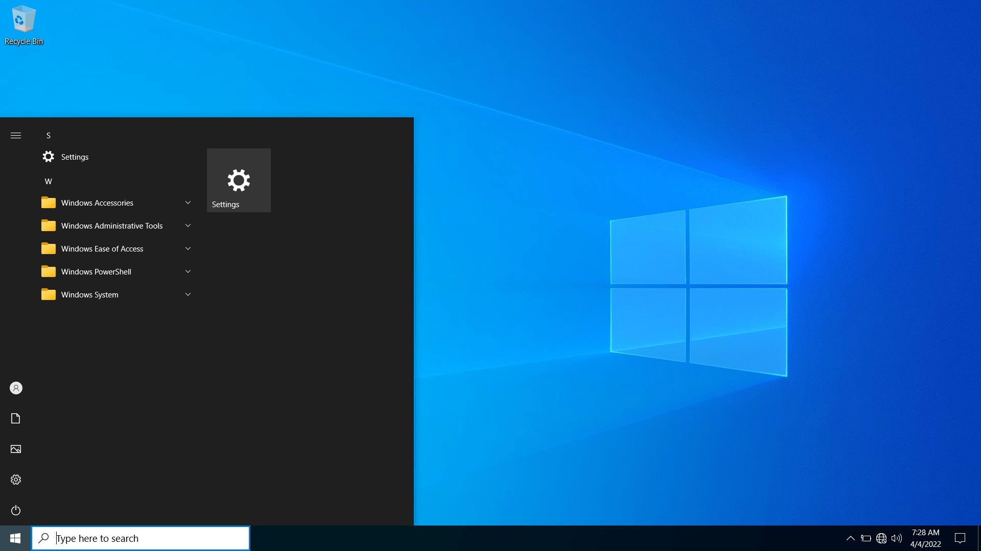

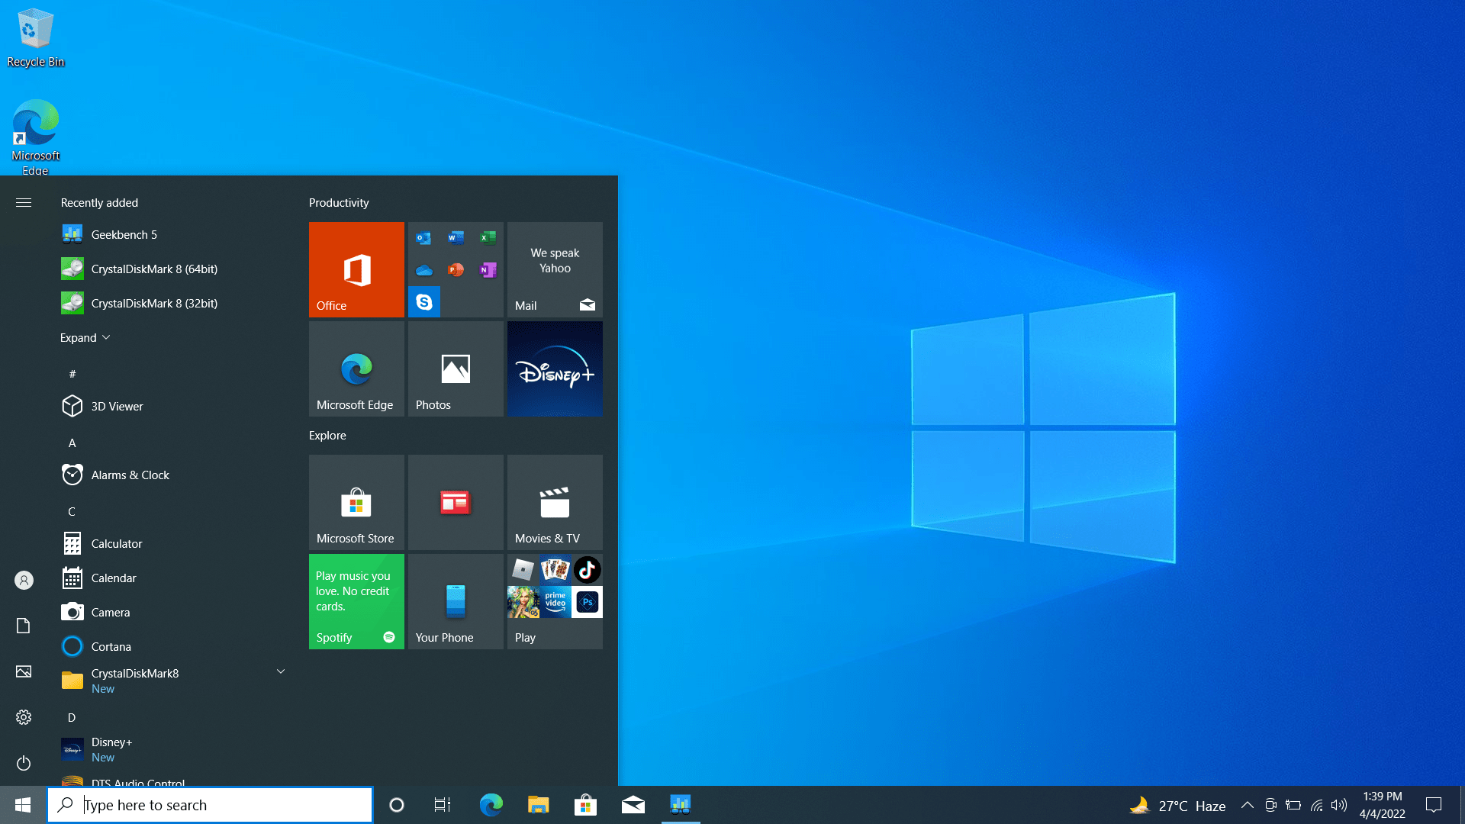

Tiny10 vs Windows 10: Start menu

Tiny10 also takes up **very little disk space** in comparison to Windows 10. On my 64-bit laptop, the Tiny10 installation took only 10.5GB of space, whereas Windows 10 ballooned to 22.2GB after a fresh installation.

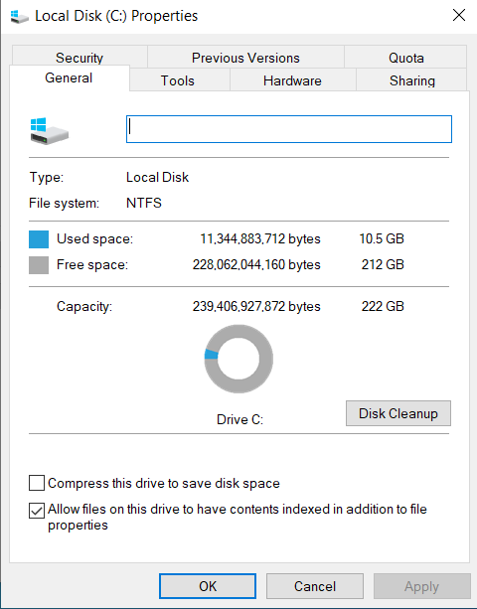

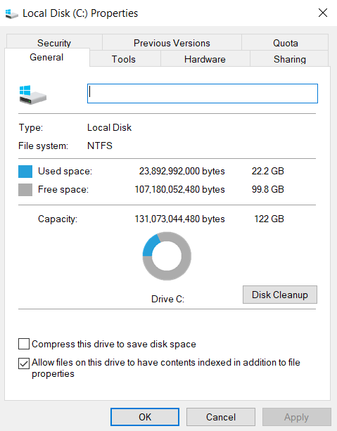

Tiny10 vs Windows 10: Disk Space after fresh installation

I also kept a keen eye on the CPU and RAM usage on Tiny10, and surprisingly, it was merely taking **1% of CPU and 1.6GB of RAM** when sitting idle. In comparison, Windows 10 kept its CPU usage in check, but RAM usage was constantly above 2.5GB. Here’s the Task Manager overview of Tiny10 and Windows 10.

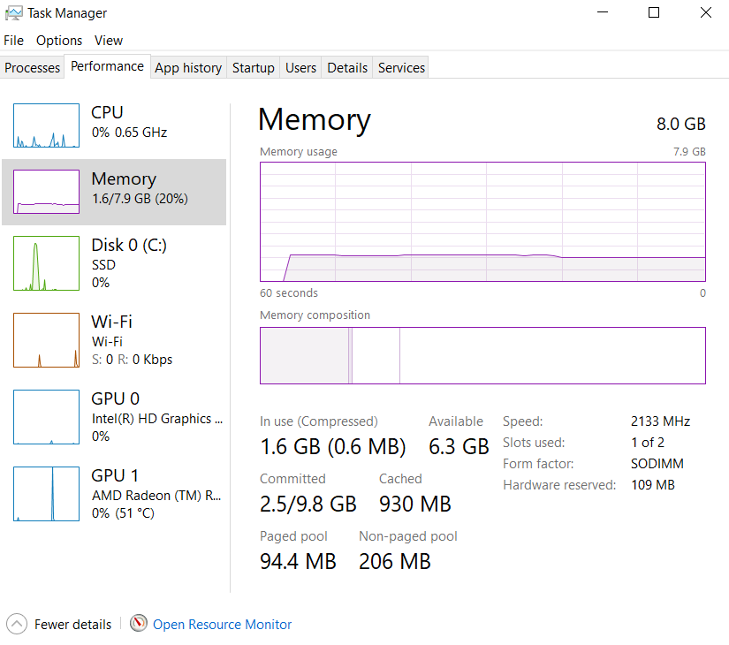

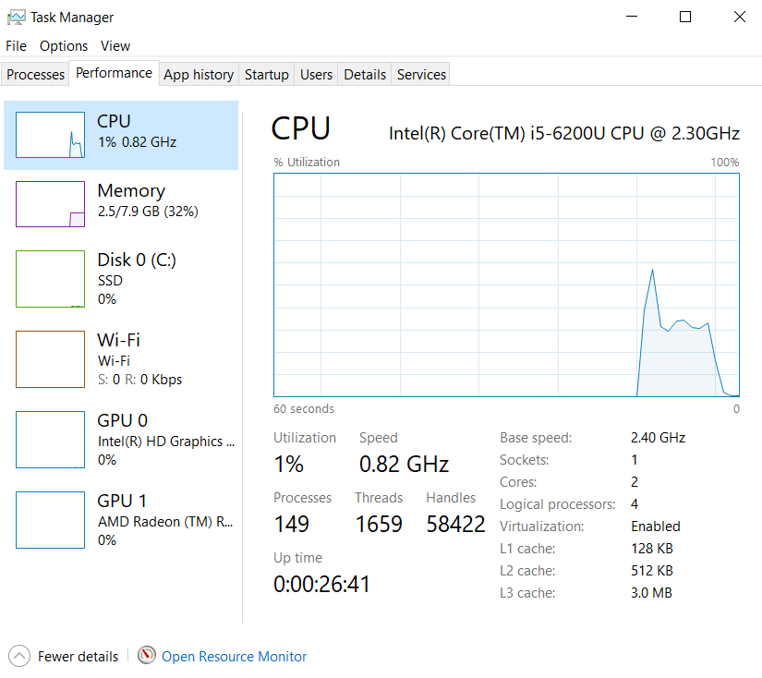

Tiny10 vs Windows 10: Task Manager

Coming to some benchmark testing between Tiny10 and vanilla Windows 10, here are some Geekbench and CrystalDiskMark results. In the Geekbench test, both OSes performed along the same lines, but in the CrystalDiskMark test, we can see that Tiny10 was able to **write data at double speeds**, which is great.

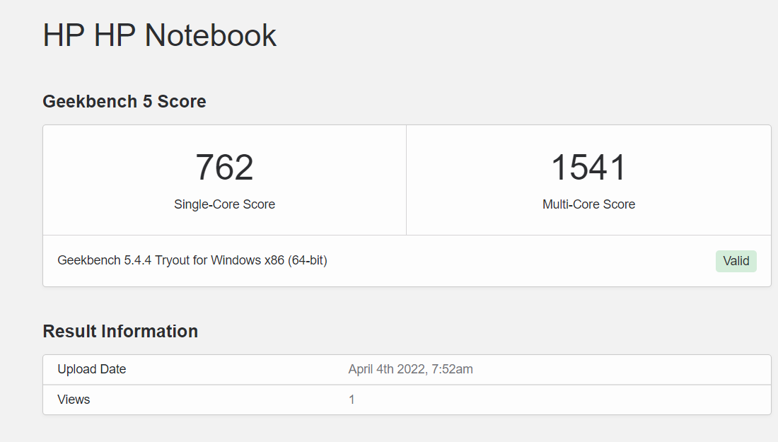

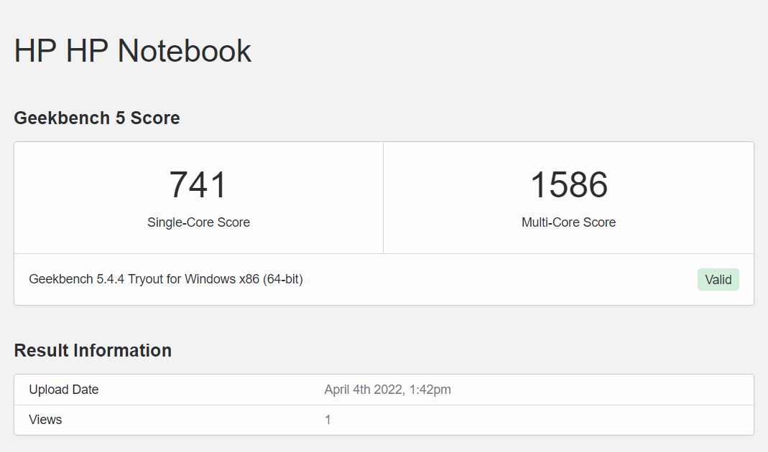

Tiny10 vs Windows 10: Geekbench scores

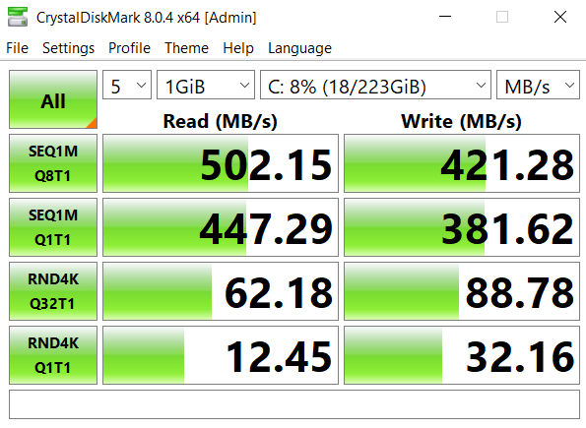

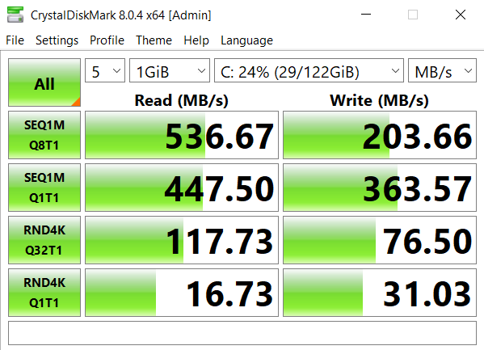

Tiny10 vs Windows 10: CrystalDiskMark Test

Finally, I also installed Steam and played CS: GO at high settings on Tiny10, and it performed decently on my 6th-gen i5- powered laptop. I got **around 20-30FPS**, similar to vanilla Windows 10. However, turning down the graphics settings to low, I was easily able to get around 45-50FPS, which is pretty decent for a low-end Windows PC.

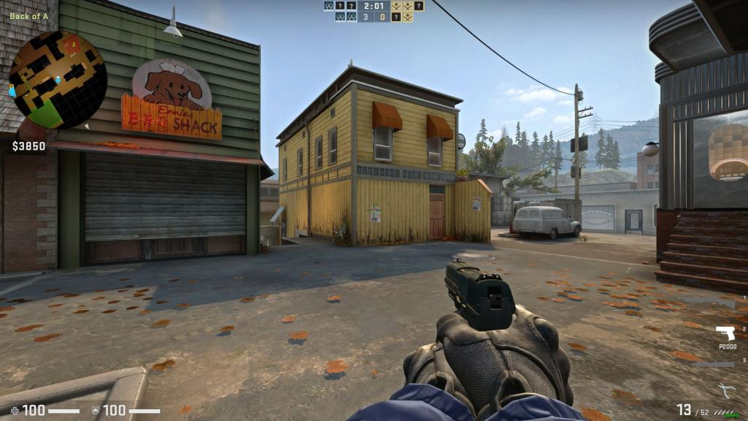CS: GO on Tiny10

**How to Install Tiny10 (Stripped Down Windows 10)**

1. Go ahead and **download the ISO image** of Tiny10 based on your system architecture: [32-bit (1.7GB)](https://twitter.com/NTDEV_/status/1505654562992050178) | [64-bit (2.4GB)](https://twitter.com/NTDEV_/status/1505656808576372753). We did a preliminary check of the files on VirusTotal and didn’t notice any red flags, so that’s a good sign.

2. After that, head to [this link](https://rufus.ie/en/) and **download Rufus** to create a bootable USB drive.

3. Now, open Rufus, plug the USB drive, select the ISO image, and click on “**Start**“. Make sure the File system is NTFS.

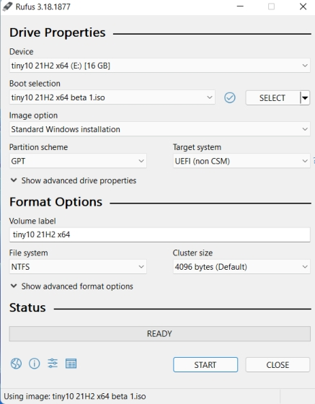

4. After the flashing process begins, we suggest you **make some downloads** in the meantime to have a hassle-free experience. There is no [browser](https://beebom.com/best-windows-10-browsers/) included in Tiny10, so we suggest downloading the standalone setup of Google Chrome from [here](https://www.google.com/intl/en/chrome/browser/desktop/index.html?standalone=1). After that, transfer it to the root directory of the flashed USB drive. Also, you can download and transfer a [tool like Driver Booster](https://beebom.com/best-free-tools-download-install-drivers-windows/) to update your drivers.

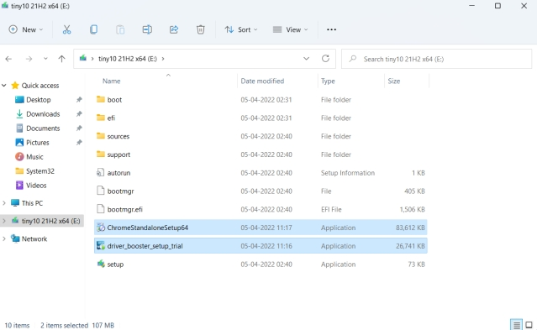

5. Next, plug the USB drive into the target PC and restart it. When the PC restarts, **press the boot key** (should be one of the function keys – F9, F8, F7, etc.). If you don’t know the boot key for your PC or laptop, look it up on the internet. Once you are on the boot selection screen, select your USB drive and hit Enter.

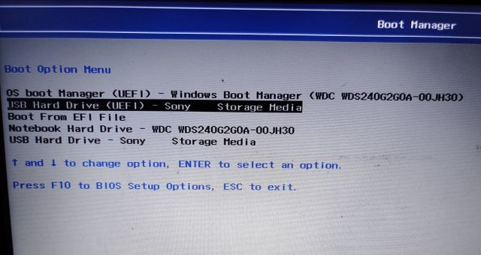

6. Your PC will now load Tiny10’s installation window, which is similar to Windows 10’s setup window. Follow the on-screen instructions and **choose your preferred drive**. Finally, click on “Next” to install the OS.

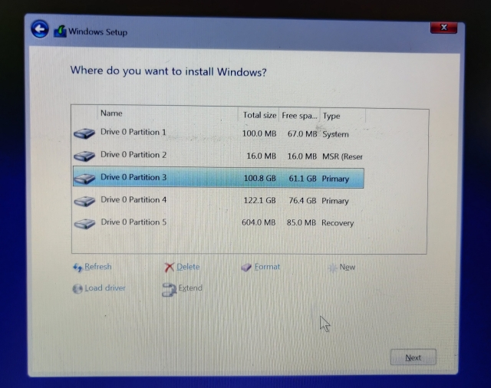

7. Once the installation is complete, you will **boot directly to Tiny10**. Enjoy the minimal Windows 10!



**Tiny10: My First Impressions**

I have extensively used Windows 10 in the past and am currently using Windows 11, and I can say that **Tiny10 has surprised me**. I used Tiny10 for a legion of tasks from playing games like CS: GO to enabling Hyper-V during my testing this week, and it **worked every single time** without throwing any tantrums. It constantly kept the CPU and RAM usage in check. I was able to do much more on Tiny10 because I feel there is still room for performing a task. It does not feel laggy at all.

* 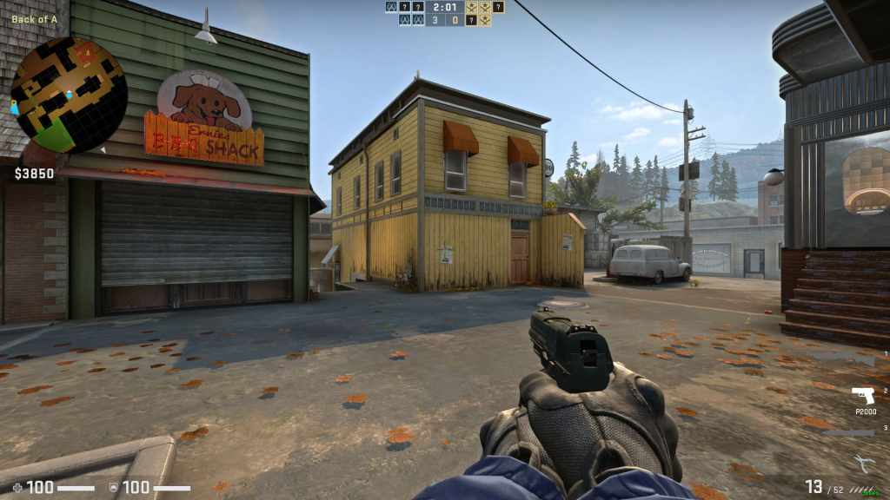
* 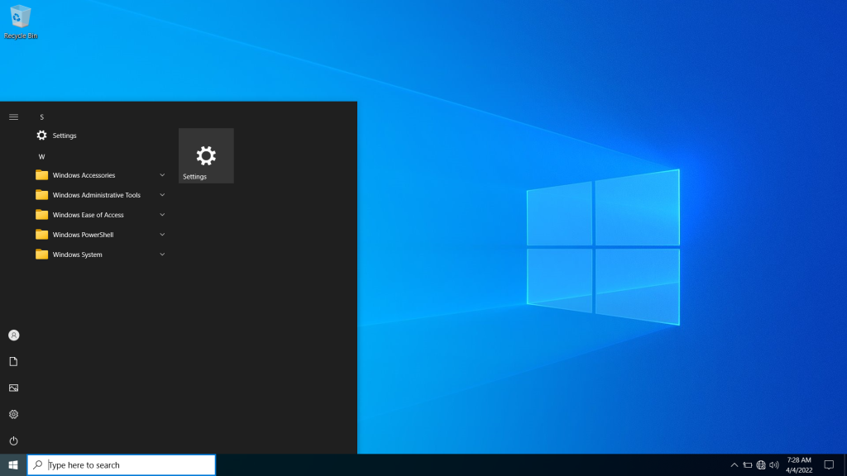
* 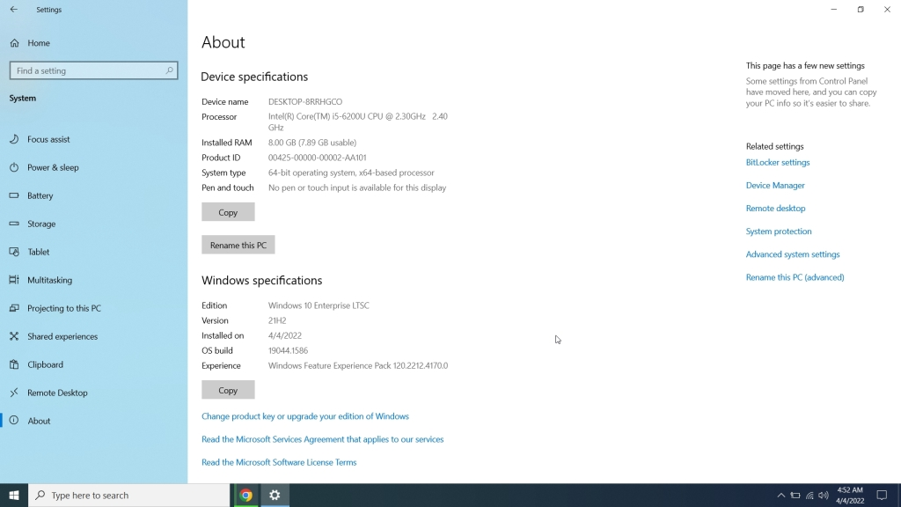
* 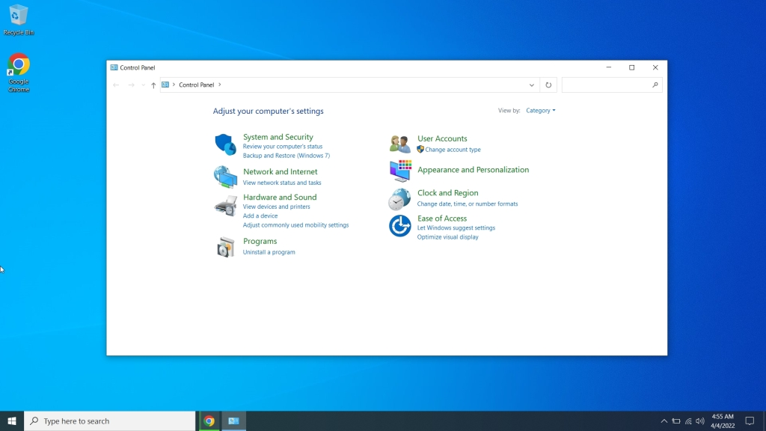
* 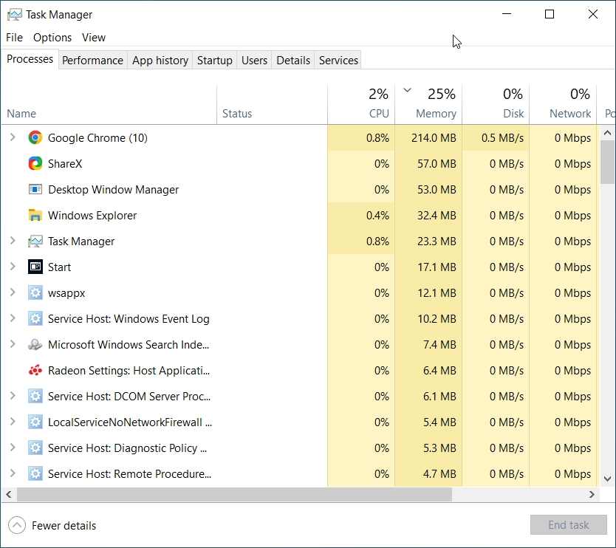
* 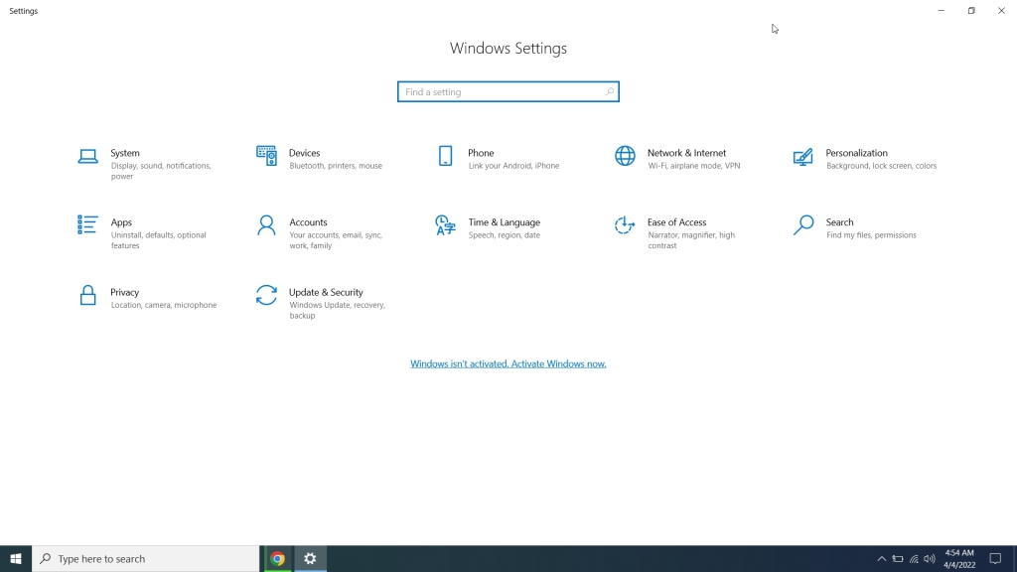
* 
* 

What is Tiny10 (Lightweight Windows 10) and How to Install It

The Start menu opens in a jiffy. There is [no Bing search integrated into the search bar](https://beebom.com/how-remove-bing-search-results-windows-11/) so search results are wicked fast, no telemetry in the background, and no weird services raking [disk usage to 100%](https://beebom.com/how-fix-100-disk-usage-windows-11/), among other things. It’s overall a smooth and pleasant experience. To sum up, don’t think twice and try Tiny10 if you are using a low-end PC or just someone having a bad experience with vanilla Windows 10. You will have to take care on the security front by [installing an antivirus on Windows 10](https://beebom.com/best-antivirus-for-windows-10/), but apart from that, you will absolutely love the clean and lightness of Tiny10 without compromising on features.

**Frequently Asked Questions**

**Q. Is Tiny10 developed by Microsoft?**

No, Tiny10 is an independent project, and it’s been developed by a developer named NTDEV.

**Q. What is the size of the Tiny10 ISO image?**

The 64-bit ISO image of Tiny10 takes up to 2.4GB of space, and the 32-bit image is around 1.7GB in size.

**Q. Can we install Tiny10 on 32-bit PCs?**

Yes, Tiny10 is supported on 32-bit computers.

**Q. Is Tiny10 an open-source project?**

No, Tiny10 is not an open-source project.

**Q. Is it safe to install Tiny10?**

While we can’t vouch for the safety of Tiny10, we did a preliminary check of the files on VirusTotal, and none of the security vendors flagged any malicious behavior. That said, it’s within your discretion if you want to install Tiny10 on your PC.

**Easily Run Windows 10 on Low-End PCs with Tiny10**

So that was everything you need to know about Tiny10 and how you can install it on any PC. I like the fact that Tiny10 offers support for 32-bit systems, which means older hardware can also benefit from this project. I hope Microsoft in the future releases a light build of Windows 11 similar to Tiny10. It will tremendously help general users who want their PC to work without slowing down. Anyway, that is all from us. If you want to [debloat Windows 11](https://beebom.com/how-debloat-windows-11-improve-performance/) and [speed up your Windows 11 PC](https://beebom.com/how-speed-up-windows-11/), follow our linked tutorials. Finally, if you have any questions, let us know in the comments section below.